**END OF MODULE ASSESSMENT:** Mock Exam

**COLLEGE:** Science

**DEPARTMENT:** School of Computer Science

**MODULE:** Networks and Network Systems

**MODULE CODE:** CMP2007M

**LEVEL:** 2

**CO-ORDINATOR:** Yvonne James

**DATE:**

**START TIME:**

**TIME ALLOWED:** 60 Minutes

**INSTRUCTIONS TO STUDENTS:**

**QUESTIONS TO ANSWER:** Answer ONE question

**MARKING SCHEME:** Questions are individually weighted

**MATERIALS PROVIDED:** None

**MATERIALS ALLOWED:** Standard non-programmable calculators Mobile phones **ARE NOT** a calculator substitute

**NOTES TO STUDENTS:** None

**Question 1**

Two of the main protocols in use for network communications are: TCP (Transmission Control Protocol) and UDP (User Datagram Protocol)

1. Discuss the advantages and disadvantages of these two protocols and discuss how they differ.

**[12 Marks]**

1. For each of the following applications determine whether you would use TCP or UDP and explain the reasons for your choice
   1. File Transfer
   2. Watching a real time streamed video
   3. Web Browsing
   4. A Voice over IP (VoIP) telephone conversation

**[8 Marks]**

1. Draw a Diagram showing how packets might traverse the internet, and how they may arrive at their destination. Include in the diagrams any acknowledgements, packet order and priority. Provide a diagram for both the TCP and the UDP protocols.

**[16 Marks]**

**Question 2**

Referring to the picture below, a network administrator is connecting hosts A and B directly through their Ethernet interfaces, as shown in the illustration. Ping attempts between the hosts are unsuccessful.

1. What could potentially be wrong? What can be done to provide connectivity between the hosts? Show any working out.

**[15 Marks]**

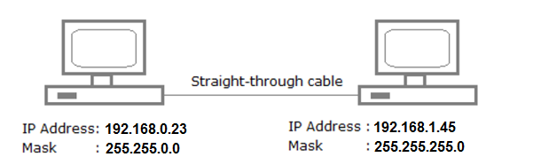

1. Explain the difference between a straight through cable and a cross-over cable.

**[5 Marks]**

**Question 3**

What are the differences between ‘Circuit Switched’ and ‘Packet Switched’ networks? Give examples of each, and provide examples of when you may use one over another, providing the advantages of each type.

**[15 Marks]**